EXPERIMENT 4 —Step-wise Solution
PART A: LOAD DATA AND BUILD REPORT
Step 1: Open the Power BI Model
We opened the Power BI model created in Experiment 3 and verified that the required tables and relationships were available. We then prepared visuals for Sales by Region, Profit by Category, Sales by Segment, and Sales Trend by Year.

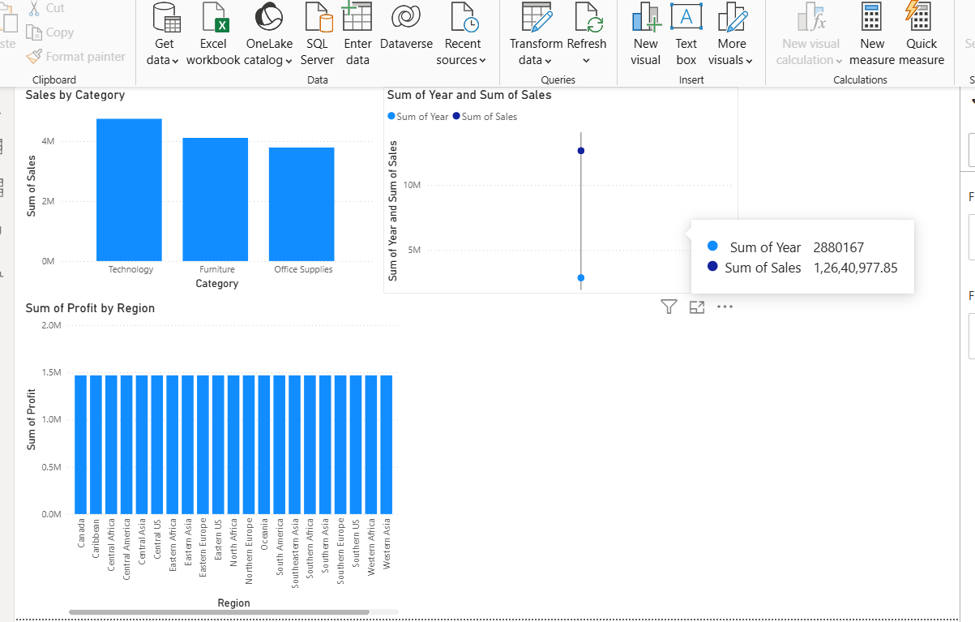
PART B: SLICE OPERATION
Step 2: Apply a Slice
A Region slicer was added to the report. We selected one region, such as West, and observed how the Sales, Profit, and Order values changed based on the selected region.
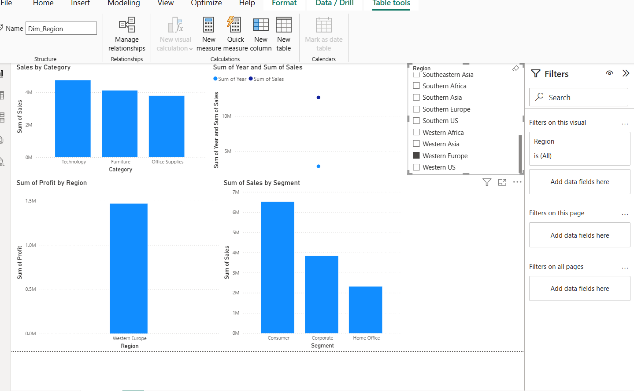

PART C: DICE OPERATION
Step 3: Apply Multiple Filters
Multiple filters were applied at the same time to perform a Dice operation. For example, we selected:
- Region = West
- Category = Technology
- Year = 2022
The resulting Sales, Profit, and Orders were analyzed for this specific combination.
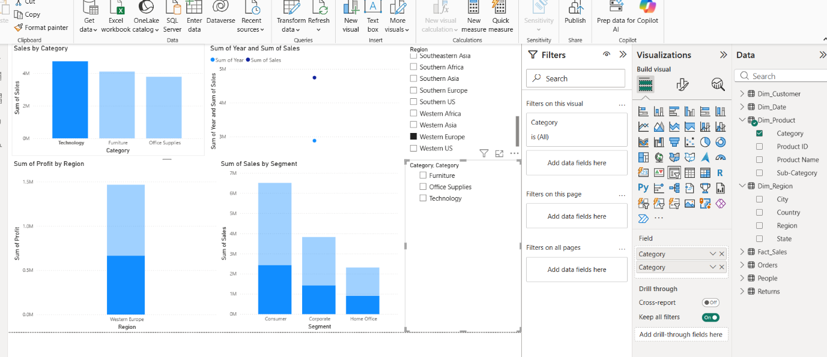

PART D: DRILL-DOWN OPERATION
Step 4: Analyze Data at Different Levels
A hierarchy was created using Region → State → City. The visual was then used in Drill-down mode to move from the regional level to individual states and cities.
This allowed us to examine sales performance in greater detail.
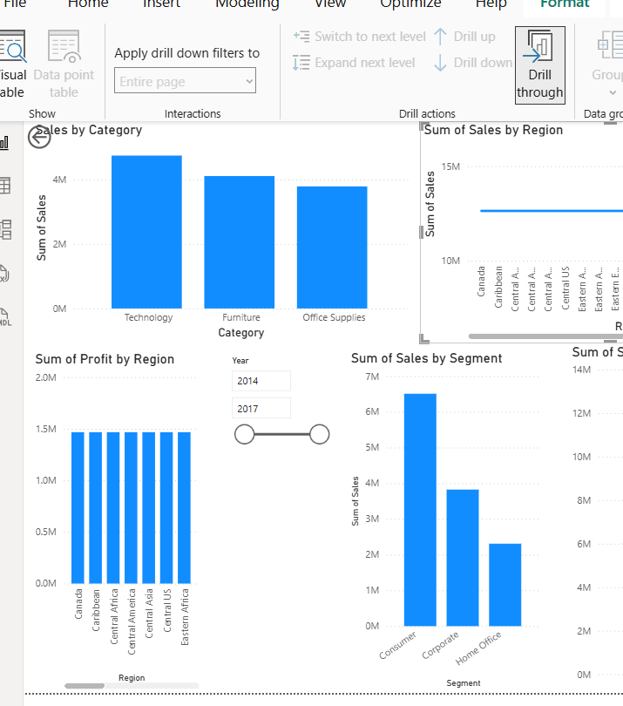

PART E: DRILL-UP OPERATION
Step 5: Return to Higher-Level Data
After analyzing the city-level information, we used Drill-up to move back from City → State → Region. The aggregated values at each level were compared to understand the overall business performance.
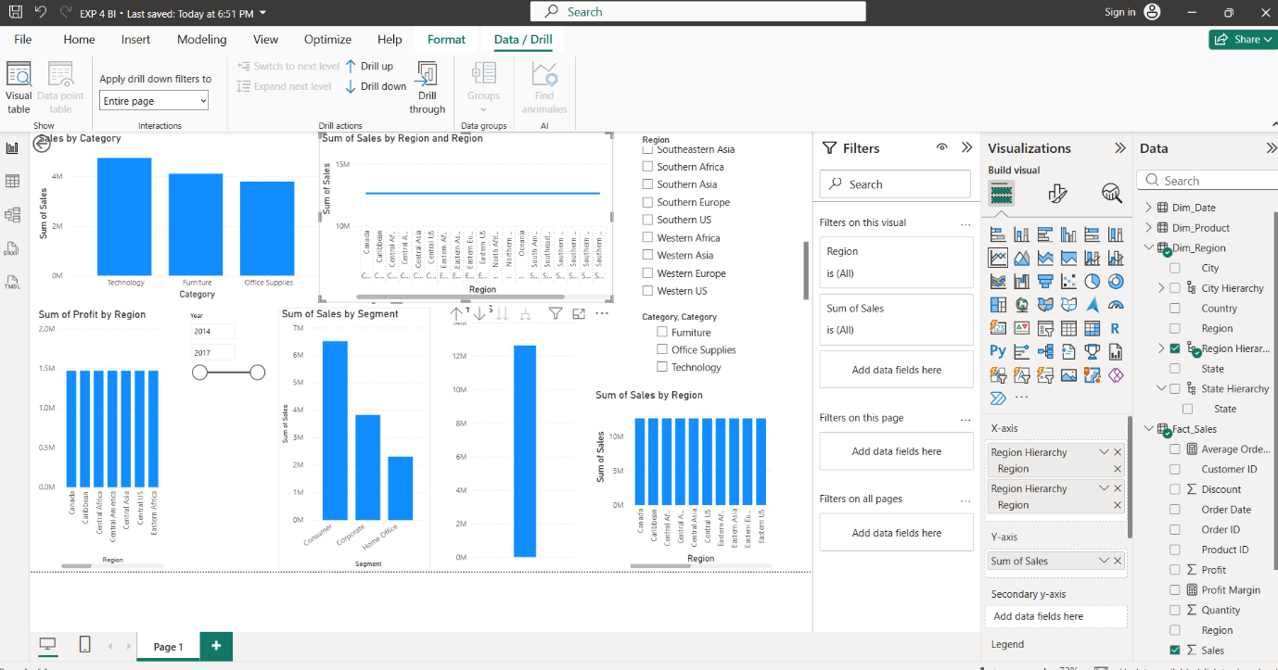
PART F: OLAP ANALYSIS
Step 6: Compare OLAP Operations
The results from Slice, Dice, Drill-down, and Drill-up were compared to understand how each operation provides a different view of the same business data.
A summary of the observations was prepared to show how these operations can support business decision-making.
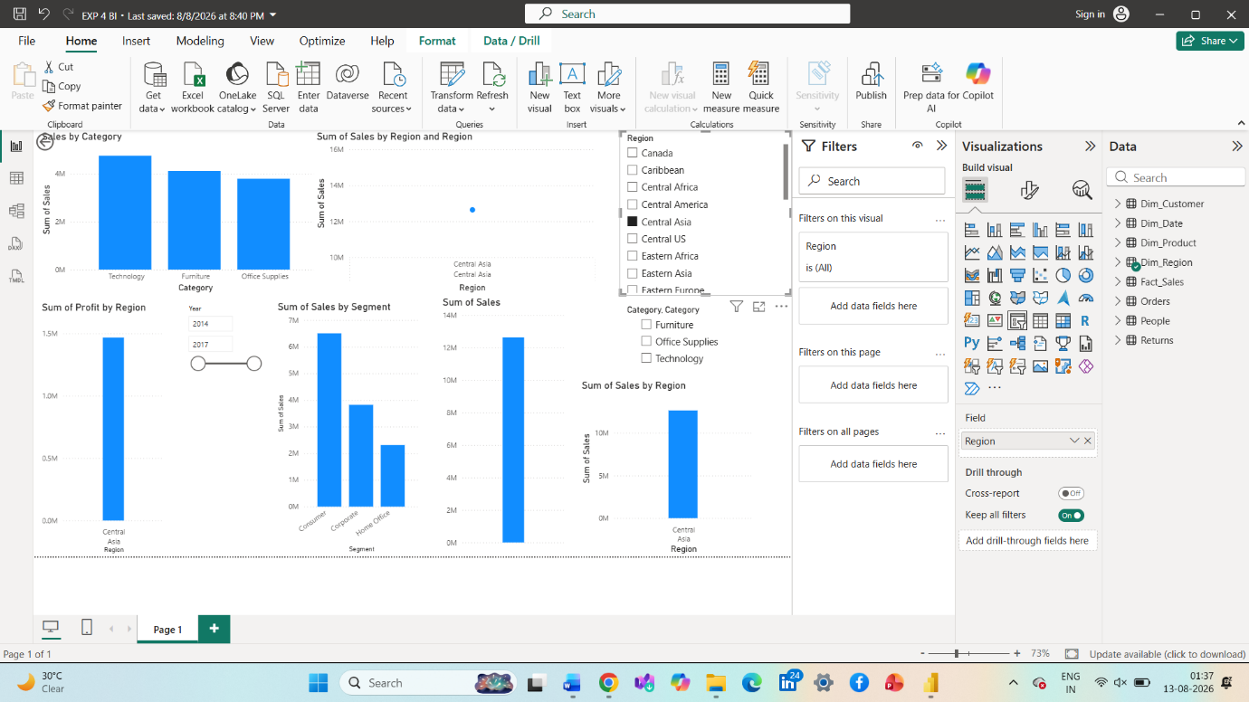
PART B: RELATIONAL AND MULTIDIMENSIONAL REPORTS (EXP5)
Step 5: Create the Relational Report
- Open the existing Power BI project.
- Add a new report page and rename it Relational Report.
- Insert a Table visual.
- Add the following fields:
  - Order ID
  - Customer Name
  - Product Name
  - Region
  - Sales
  - Profit
- Sort Sales in descending order.
- Apply a visual-level filter to display records where Profit is greater than zero.
Step 6: Create the Matrix Report
- Add a new report page and rename it Matrix Report.
- Insert a Matrix visual.
- Add Geo_Hierarchy to Rows.
- Add Total Sales, Total Profit, and Quantity to Values.
- Expand the hierarchy from Region to State and City.
- Compare the results at different geographical levels.
Step 7: Create Comparative Analysis
- Add a new page named Comparative Analysis.
- Create a visual for Sales by Category.
- Create a visual for Profit by Region.
- Create a visual for Top 10 Customers by Sales.
- Create a visual for Sales Trend by Year.
- Apply the required filters and format the visuals.
Step 8: Create the Interactive Dashboard
- Add a new page named Dashboard.
- Insert KPI cards for Total Sales, Total Profit, Total Orders, and Quantity.
- Add a Sales by Category visual.
- Add a Profit by Region visual.
- Add a Sales Trend by Year visual.
- Add slicers for Region, Category, and Year.
- Test the slicers to verify that the visuals respond dynamically.
PART C: EXECUTIVE DASHBOARD DEVELOPMENT (EXP6)
Step 9: Create the Executive Dashboard Page
- Add a new report page and rename it Executive Dashboard.
- Identify the key business metrics required by management.
- Create KPI cards for:
  - Total Sales
  - Total Profit
  - Total Orders
  - Profit Margin (%)
- Arrange the KPI cards across the top of the dashboard.
Step 10: Create the Dashboard Visualizations
- Create Sales by Region using Region and Total Sales.
- Create Sales by Category using Category and Total Sales.
- Create Monthly Sales Trend using Month and Total Sales.
- Create Top 10 Customers by Sales using Customer Name and Total Sales.
- Create Profit by Segment using Segment and Total Profit.
- Format the visuals for readability and consistency.
Step 11: Add Interactive Features
- Add a slicer for Region.
- Add a slicer for Category.
- Add a slicer for Year.
- Test each slicer by selecting different values.
- Verify that the KPI cards and charts respond to the selections.
- Clear the slicers to restore the overall dashboard results.
PART D: BUSINESS SCORECARD DEVELOPMENT
Step 12: Create the Business Scorecard Page
- Add a new report page and rename it Business Scorecard.
- Insert a single Table visual.
- Add the following measures to the same visual in this order:
- Total Sales
- Sales Target
- Sales Achievement (%)
- Sales Status
- Total Profit
- Profit Target
- Profit Achievement (%)
- Profit Status
- Total Orders
- Order Target
- Orders Achievement (%)
- Orders Status
- Set the visual title to GLOBAL SUPERSTORE – BUSINESS SCORECARD.
- Adjust the column widths to display all measures clearly.
Step 13: Calculate KPI Achievement
- Compare actual Sales with the Sales Target.
- Compare actual Profit with the Profit Target.
- Compare actual Orders with the Order Target.
- Calculate achievement using Actual divided by Target.
- Format achievement measures as percentages.
- Display the corresponding status for each KPI.
Step 14: Apply Conditional Formatting
- Select the Business Scorecard Table visual.
- Open Format visual.
- Locate the conditional formatting options for the achievement fields.
- Apply the following performance colors:
  - Achieved: Green
  - Partially Achieved: Yellow or Orange
  - Not Achieved: Red
- Verify that the scorecard displays the actual values, targets, achievement percentages, and statuses.
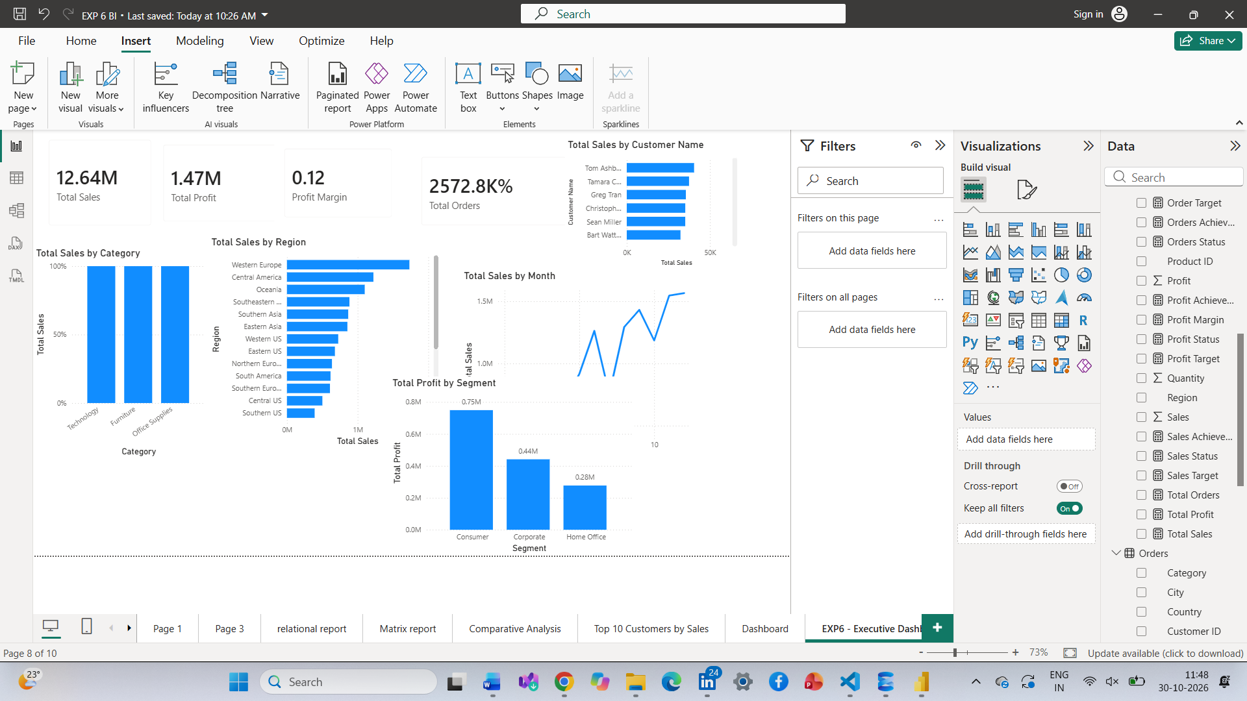
PART E: BUSINESS ANALYSIS AND RECOMMENDATIONS
Step 15: Identify the Best and Worst Performing Regions
- Open the Executive Dashboard page.
- Examine the Sales by Region visual.
- Compare the Total Sales values of all regions.
- Identify the region with the highest sales as the Best Performing Region.
- Identify the region with the lowest sales as the Worst Performing Region.
Step 16: Identify the Most and Least Profitable Categories
- Create or use a Table visual.
- Add Category from Dim_Product.
- Add Total Profit.
- Sort Total Profit in descending order.
- Identify the category with the highest profit as the Most Profitable Category.
- Identify the category with the lowest profit as the Least Profitable Category.
Step 17: Analyze the Dashboard Findings
- Examine the KPI cards.
- Review regional sales performance.
- Compare sales across product categories.
- Analyze monthly sales trends.
- Examine customer sales performance.
- Compare profit across customer segments.
- Review the Business Scorecard to evaluate actual performance against targets.
Step 18: Provide a Business Recommendation
Based on the dashboard findings:
- Strengthen marketing and distribution activities in the best-performing region.
- Investigate the reasons for lower sales in the weakest-performing region.
- Promote product categories that generate higher profits.
- Review the pricing and costs of less profitable categories.
- Use the dashboard and scorecard regularly to support data-driven decisions.
PART F: FINAL REVIEW AND SAVING
Step 19: Verify the Complete Power BI Report
Check that the report contains:
- Initial data model and relationships.
- Slice and Dice report.
- Drill-Down report.
- Relational Report.
- Matrix Report.
- Comparative Analysis.
- Interactive Dashboard.
- Executive Dashboard.
- Business Scorecard.
Step 20: Save the Final Project
- Review all report pages.
- Verify the KPI cards, charts, tables, and slicers.
- Check the Business Scorecard values and formatting.
- Save the final Power BI project using Ctrl + S.
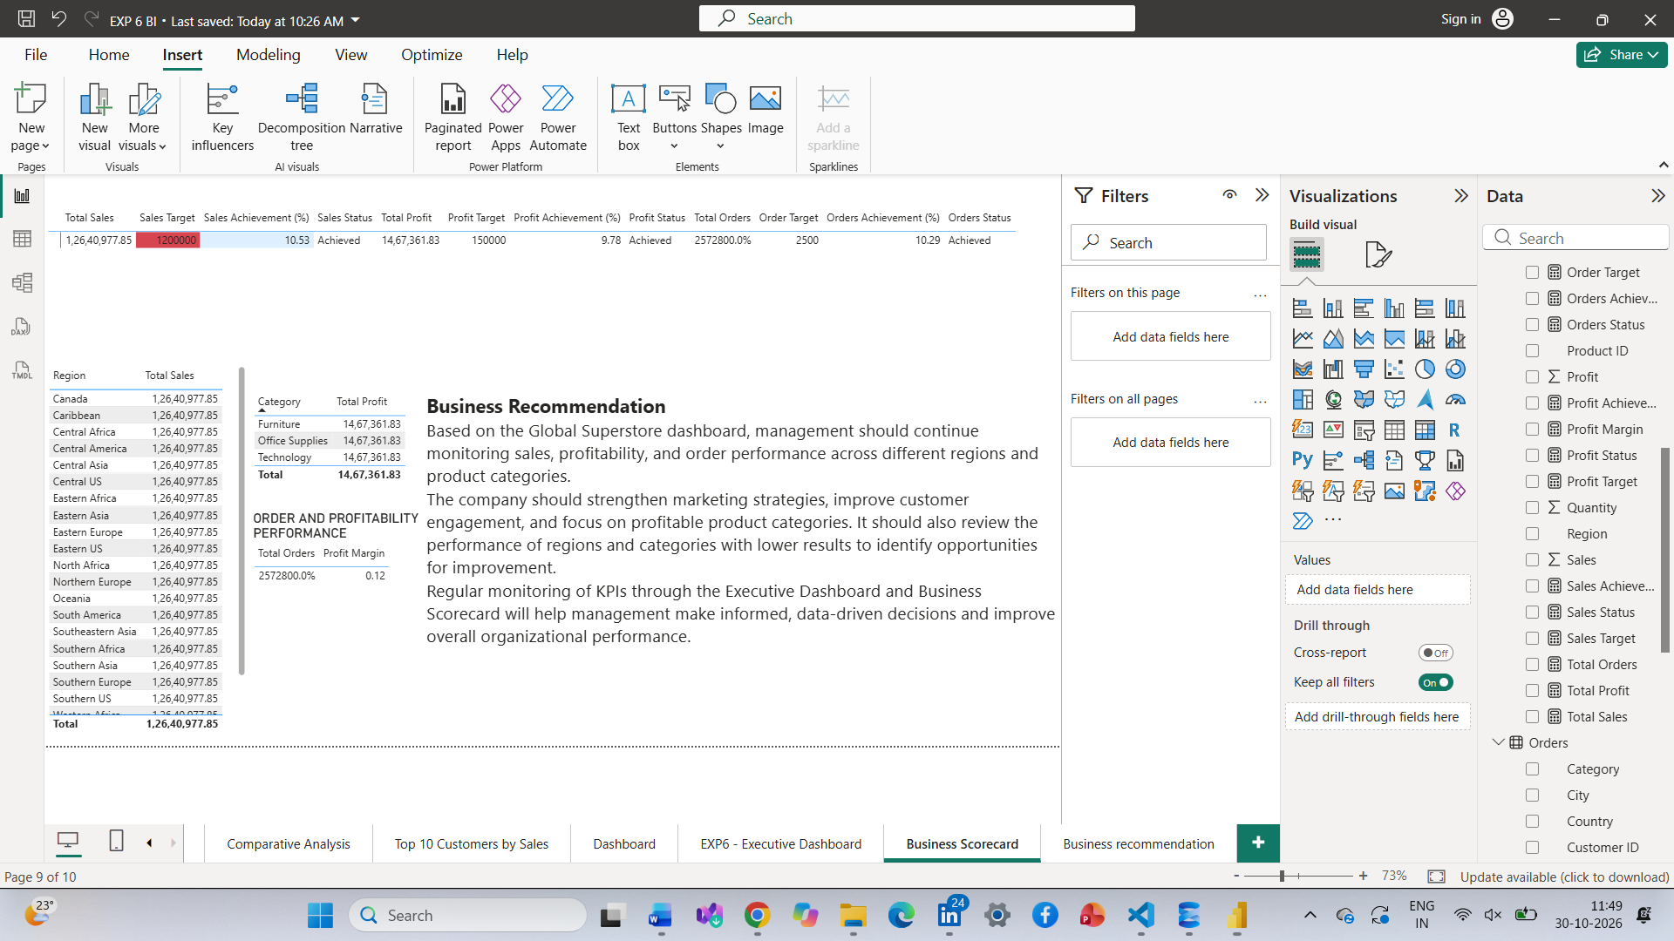
RESULT
The complete Business Intelligence report was developed using Microsoft Power BI by combining data preparation, relational and multidimensional reporting, comparative analysis, interactive dashboard development, and KPI-based scorecard creation. The final report supports organizational performance monitoring, business analysis, and data-driven decision-making.

